**PROJECT MANAGEMENT**

**Summary:**

We have used the Agile process method to implement our project. We have divided our total project into four increments. We have utilized our challenges also as a part of project. We have used the Scrumdo application for the planning and management of our project. As a part of project development in each part we have shared the total work equally between all of our team members like some people are working on the backend and others are working on the front end.

Here we are providing the screen shots for the tasks that have been scheduled in each increments.

**First Increment:**

Jaya Sai Krishna- user registration with validations

Krishna Chaitanya- Fixed location

Rahul- location service

Naveen- muut service

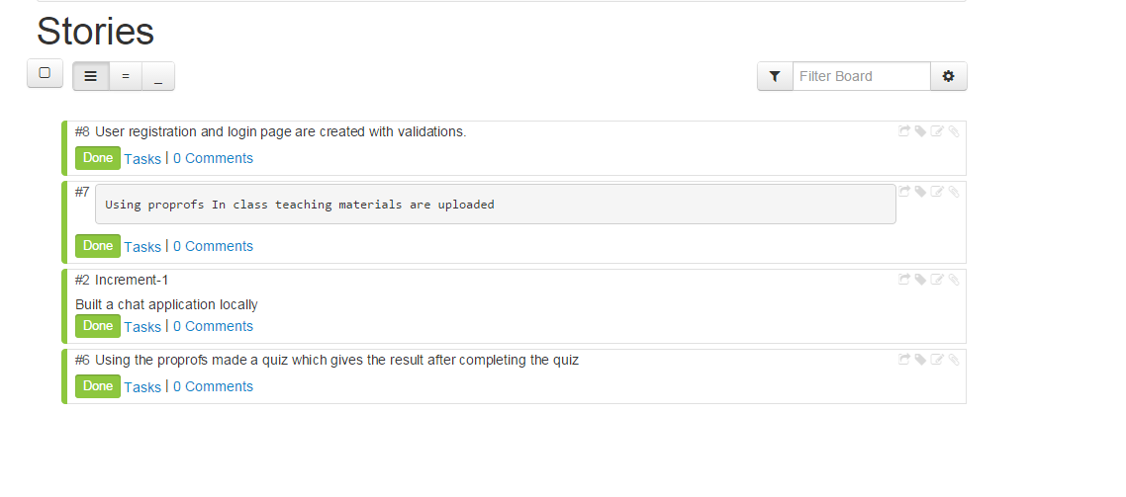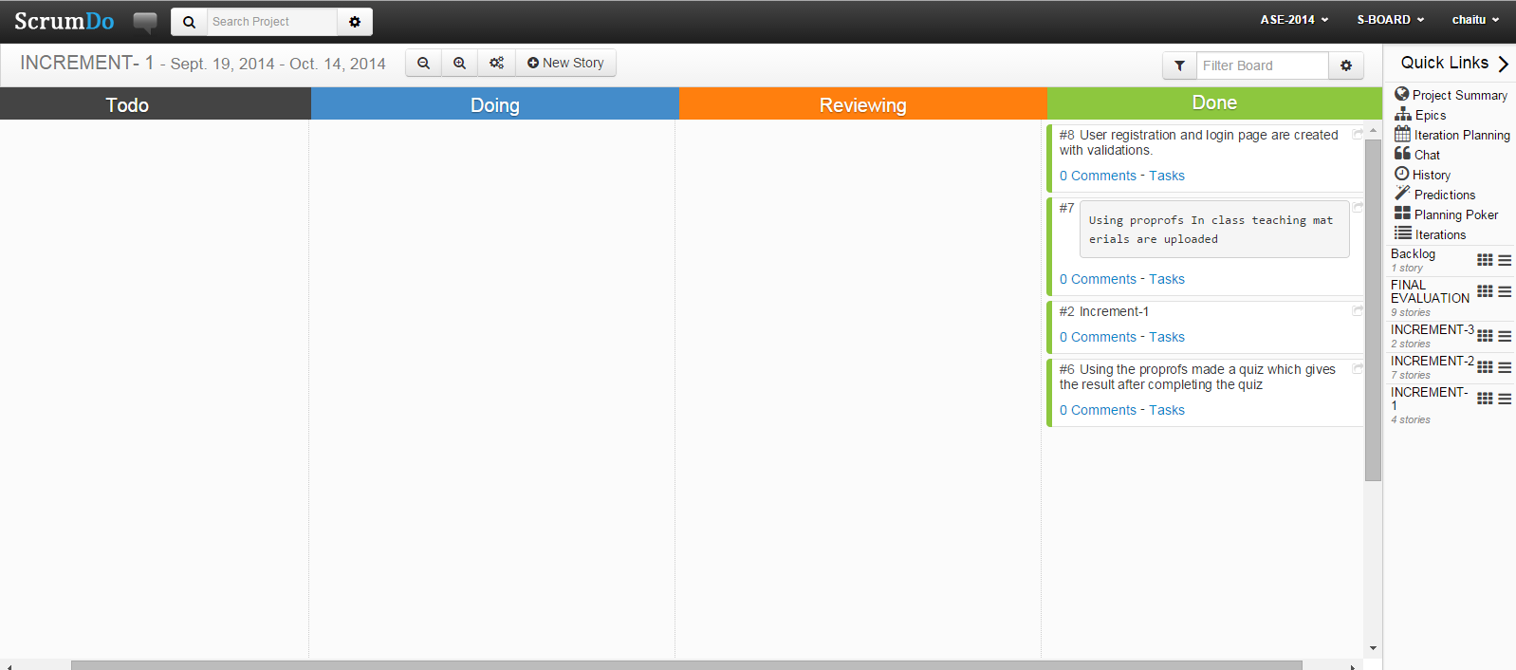

**Second Increment:**

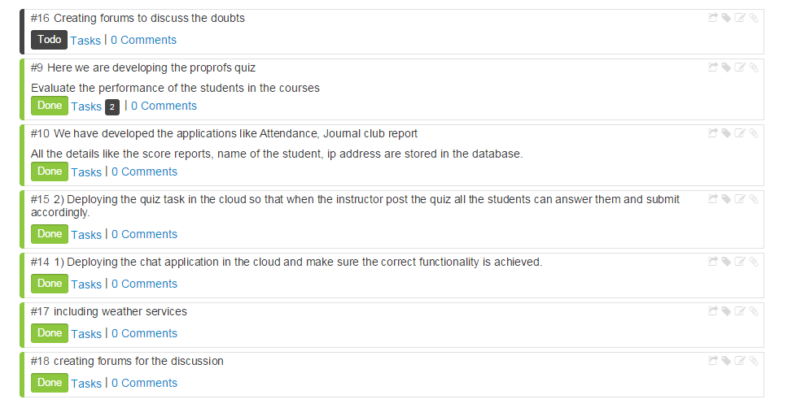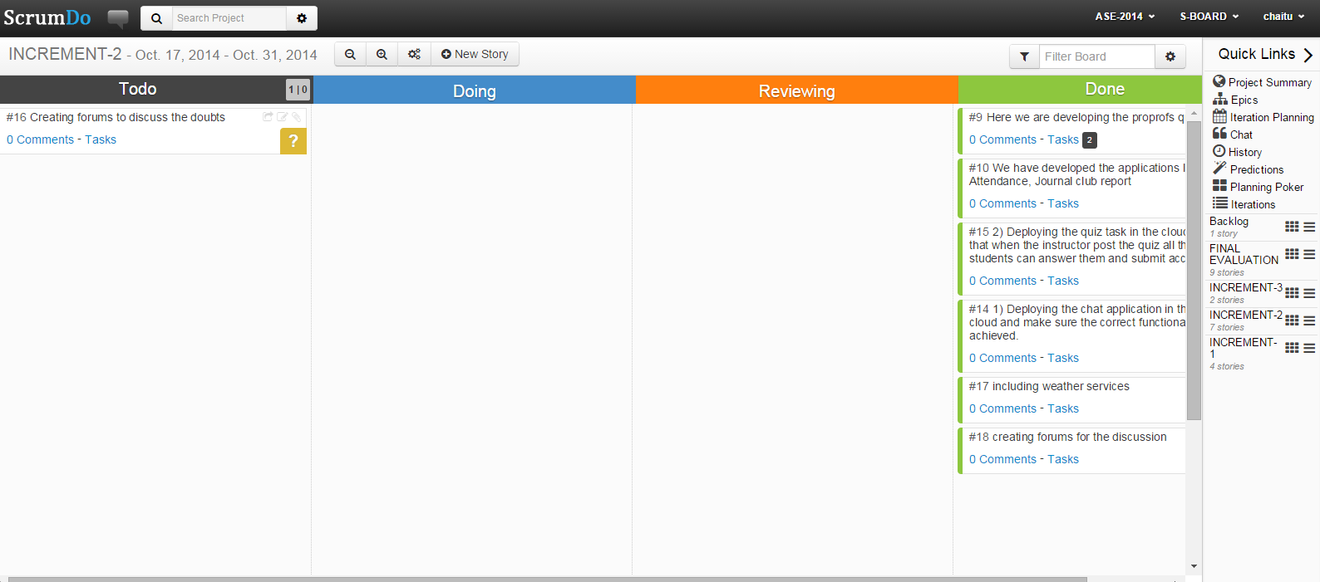

**Third Increment:**

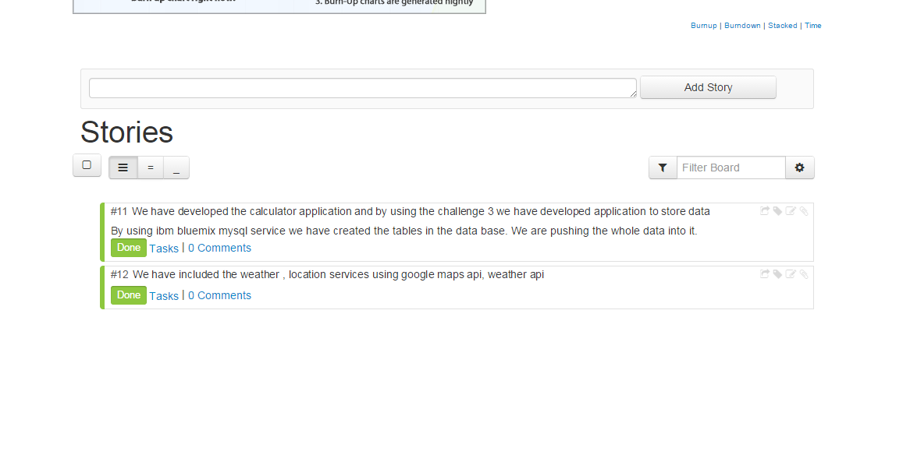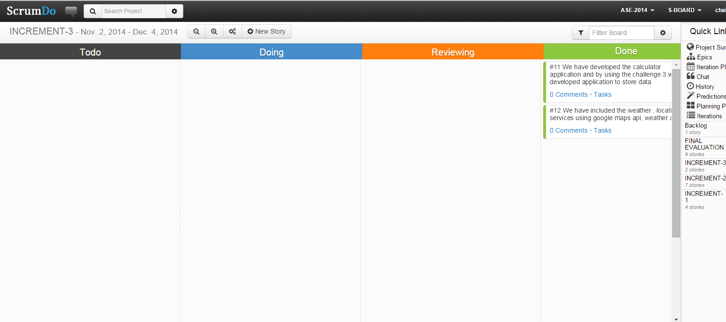

**Final Report:**

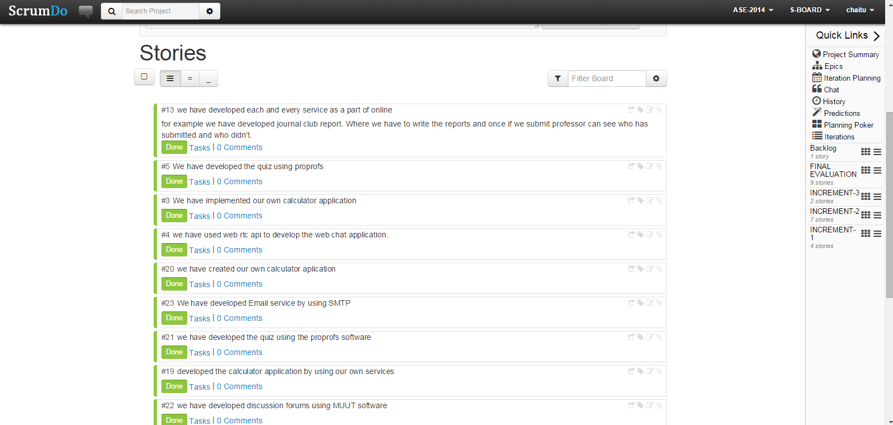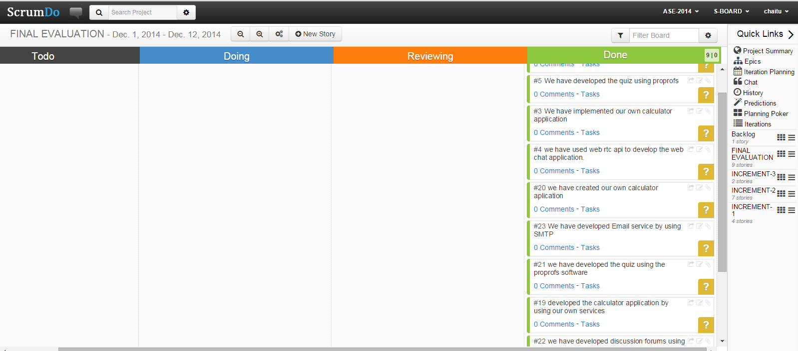

JAYA SAI KRISHNA – Calculator application, Email service, quiz

Krishna Chaitanya - Attendance, Email service, Roster

Rahul - Location services, weather services, proprofs

Naveen - Discussion forums using muut service, Location services

https://www.scrumdo.com/projects/project/s-board/iteration/117498